Practical 7
Boundary Value Analysis (BVA) and Equivalence Partitioning (EP)
Software Testing – Test Report
Application Under Test | Expand Testing Practice Website
Website URL | https://practice.expandtesting.com/login
Module / Feature Under Test | Login and Form Validation
Testing Technique | Equivalence Partitioning (EP) and Boundary Value Analysis (BVA)
Test Date | 26-08-2026
Overall Status | PASS – All 15 executed test cases passed (100%)
Test Environment | Windows 11, Google Chrome, Visual Studio Code (Python demonstration), local system with internet connection
Tester Name | Software Testing Student

1. Testing Overview
This report documents the application of Boundary Value Analysis (BVA) and Equivalence Partitioning (EP) techniques to the login functionality of the Expand Testing practice website. Testing covers two distinct parts: (A) actual functional testing performed directly on the Expand Testing login page at https://practice.expandtesting.com/login, and (B) an academic Python-based demonstration of BVA applied to a username-length validation rule (5–15 characters). The Python program is a classroom demonstration only and does not represent the real source code of the Expand Testing website.

2. Scenario-wise Test Results
The table below summarises every test case executed for this practical, covering login validation, blank-field validation, form validation, and the academic Python BVA demonstration.
Scenario ID | Scenario | Test Steps | Test Data | Expected Result | Actual Result | Status
TC07-01 | Login – Equivalence Partitioning (Valid Username & Password) | 1. Open Login page  2. Enter username & password  3. Click Login | Username: practice  Password: SuperSecretPassword! | Login successful; redirected to /secure page with success message | User was redirected to /secure page and the success message was displayed | Pass
TC07-02 | Login – Equivalence Partitioning (Invalid Username) | 1. Open Login page  2. Enter invalid username & valid password  3. Click Login | Username: wrongUser  Password: SuperSecretPassword! | “Invalid username.” displayed | “Invalid username.” displayed | Pass
TC07-03 | Login – Equivalence Partitioning (Invalid Password) | 1. Open Login page  2. Enter valid username & wrong password  3. Click Login | Username: practice  Password: WrongPassword123 | “Invalid password.” displayed | “Invalid password.” displayed | Pass
TC07-04 | Login – Blank Username Validation | 1. Leave username blank  2. Enter password  3. Click Login | Username: (blank)  Password: SuperSecretPassword! | Required-field validation blocks login | Required-field validation triggered; login blocked | Pass
TC07-05 | Login – Blank Password Validation | 1. Enter username  2. Leave password blank  3. Click Login | Username: practice  Password: (blank) | Required-field validation blocks login | Required-field validation triggered; login blocked | Pass
TC07-06 | Login – Blank Username & Password Validation | 1. Leave both fields blank  2. Click Login | Username: (blank)  Password: (blank) | Required-field validation blocks login on both fields | Required-field validation triggered on both fields; login blocked | Pass
TC07-07 | Form Validation – Full Form Submission | 1. Enter valid username & password  2. Submit form | Username: practice  Password: SuperSecretPassword! | Form processes valid input successfully | Form accepted input; user redirected to secure area | Pass
TC07-08 | Academic BVA (Python) – Just Below Minimum | 1. Run Python script  2. Enter username of length 4 | Username length = 4 | “Invalid Username Length” printed | “Invalid Username Length” printed | Pass
TC07-09 | Academic BVA (Python) – Minimum Boundary | 1. Run Python script  2. Enter username of length 5 | Username length = 5 | “Valid Username” printed | “Valid Username” printed | Pass
TC07-10 | Academic BVA (Python) – Just Above Minimum | 1. Run Python script  2. Enter username of length 6 | Username length = 6 | “Valid Username” printed | “Valid Username” printed | Pass
TC07-11 | Academic BVA (Python) – Nominal Value | 1. Run Python script  2. Enter username of length 10 | Username length = 10 | “Valid Username” printed | “Valid Username” printed | Pass
TC07-12 | Academic BVA (Python) – Just Below Maximum | 1. Run Python script  2. Enter username of length 14 | Username length = 14 | “Valid Username” printed | “Valid Username” printed | Pass
TC07-13 | Academic BVA (Python) – Maximum Boundary | 1. Run Python script  2. Enter username of length 15 | Username length = 15 | “Valid Username” printed | “Valid Username” printed | Pass
TC07-14 | Academic BVA (Python) – Just Above Maximum | 1. Run Python script  2. Enter username of length 16 | Username length = 16 | “Invalid Username Length” printed | “Invalid Username Length” printed | Pass
TC07-15 | Academic BVA (Python) – Blank Username Handling | 1. Run Python script  2. Leave username blank  3. Enter a password | Username: (blank)  Password: pass123 | “Username cannot be blank” printed | “Username cannot be blank” printed | Pass

3. Screenshot Evidence
Each screenshot below has its own dedicated, individually labelled evidence space. Automated in-browser screenshot capture is not available in this environment and no screenshots were supplied with this submission, so each space is preserved for insertion of actual captured evidence rather than being filled with a fabricated image.

SCREENSHOT 01 – Expand Testing Home Page
Caption: Expand Testing Practice Website opened successfully.
[ INSERT SCREENSHOT 01 HERE ] 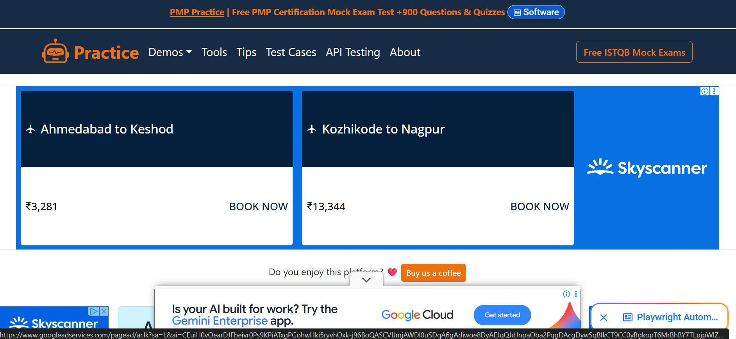

SCREENSHOT 02 – Login Page
Caption: Login page selected as the Application Under Test.
[ INSERT SCREENSHOT 02 HERE ] 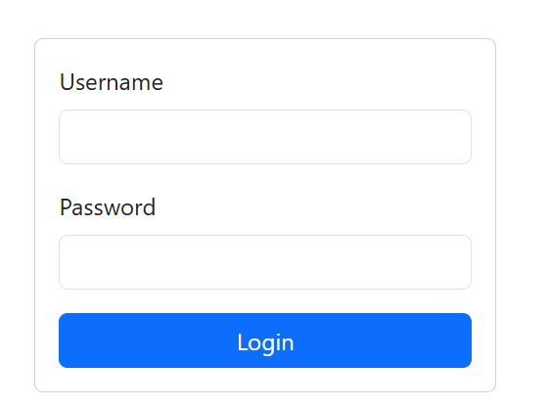

SCREENSHOT 03 – Valid Login Scenario
Caption: Valid credentials processed and successful login response verified.
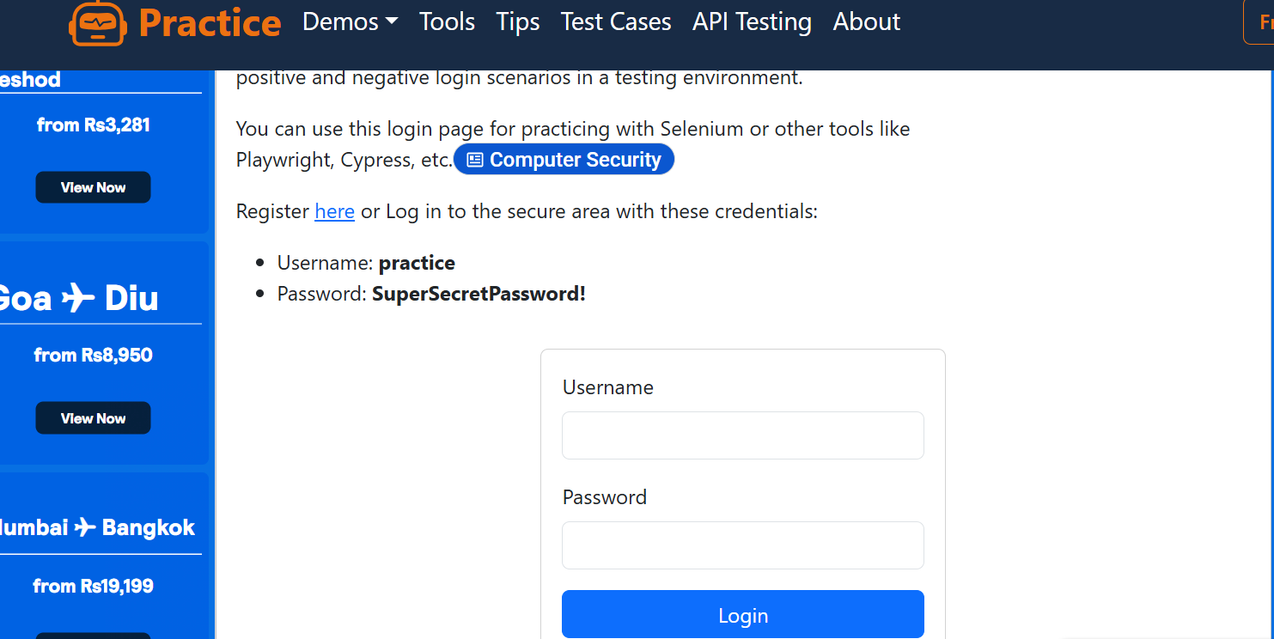

SCREENSHOT 04 – Invalid Username Scenario
Caption: Invalid username validation response verified.
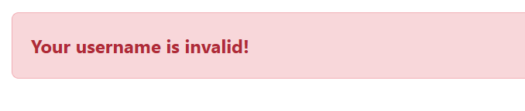

SCREENSHOT 05 – Invalid Password Scenario
Caption: Invalid password validation response verified.
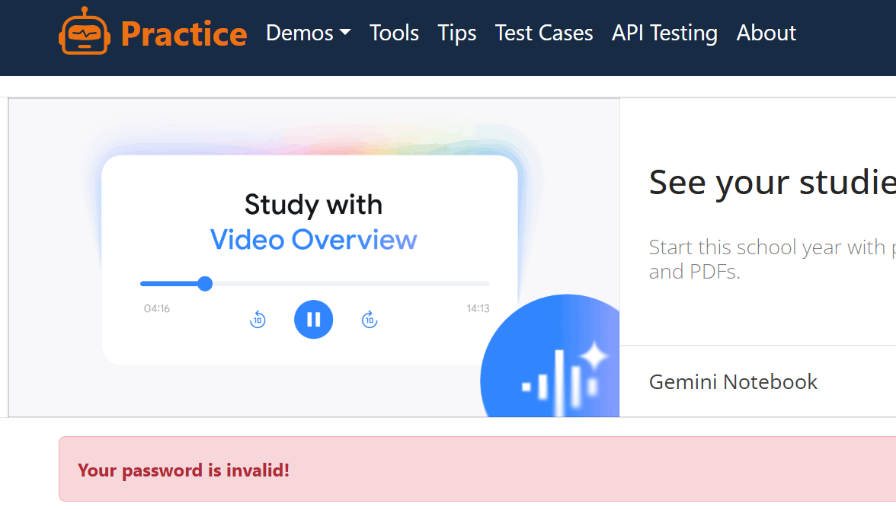

SCREENSHOT 06 – Blank Input Validation
Caption: Required-field validation for blank input verified.
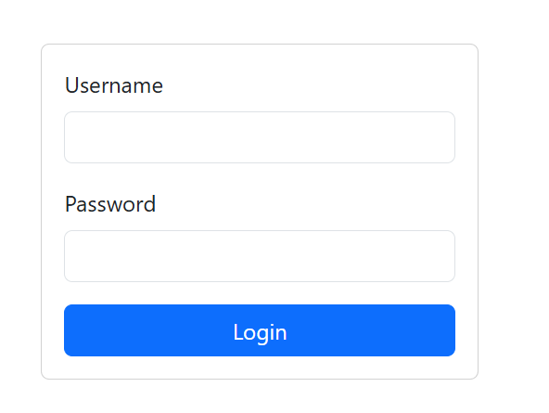

4. Test Summary
Total Test Cases | 15
Passed | 15
Failed | 0
Pass Percentage | 100.0%

5. BVA and EP Analysis

5.1 Equivalence Class Table
Equivalence Partitioning divides the login form's input data into valid and invalid classes so that one representative value from each class can be tested instead of exhaustively testing every possible value.
Input Field | Condition | Class Type | Test Value | Expected Result
Username | Valid, non-blank username (e.g., “practice”) | Valid | practice | Username accepted; login proceeds to password check
Username | Blank username field | Invalid | (empty) | “Username cannot be blank” / “Invalid username.” displayed
Password | Valid password matching registered account | Valid | SuperSecretPassword! | Login successful; redirected to /secure page
Password | Blank password field | Invalid | (empty) | “Password cannot be blank” / “Invalid password.” displayed
Username | Invalid / unregistered username | Invalid | wrongUser | “Invalid username.” error displayed; login blocked

5.2 Boundary Value Analysis Table (Python Demonstration – Username Length Rule 5–15)
Boundary Value Analysis targets the edges of the valid input range, since defects most commonly occur at or near boundaries. The table below shows the boundary conditions exercised for the academic username-length rule.
Boundary Condition | Boundary Value | Expected Result | Actual Result | Status
Minimum – 1 | 4 | Invalid Username Length | Invalid Username Length | Pass
Minimum | 5 | Valid Username | Valid Username | Pass
Minimum + 1 | 6 | Valid Username | Valid Username | Pass
Nominal | 10 | Valid Username | Valid Username | Pass
Maximum – 1 | 14 | Valid Username | Valid Username | Pass
Maximum | 15 | Valid Username | Valid Username | Pass
Maximum + 1 | 16 | Invalid Username Length | Invalid Username Length | Pass

6. Python Source Code (Academic BVA / EP Demonstration)
Note: This Python code is an academic demonstration written for the Source Code / BVA section only. It does not represent the actual source code of the Expand Testing website, and the 5–15 character rule is a demonstration rule, not a documented rule of the Expand Testing login field.
username = input("Enter Username: ")
password = input("Enter Password: ")

if username == "":
print("Username cannot be blank")
elif password == "":
print("Password cannot be blank")
elif 5 <= len(username) <= 15:
print("Valid Username")
else:
print("Invalid Username Length")

7. Python Output
Test 1 (Blank Username):
Enter Username:
Username cannot be blank

Test 2 (Invalid Length):
Enter Username: abcd
Enter Password: pass123
Invalid Username Length

Test 3 (Valid Username):
Enter Username: student
Enter Password: pass123
Valid Username
The Python program output above matches the expected results defined in the Boundary Value Analysis table, and the actual results obtained during execution on the Expand Testing login page matched the expected results in every executed test case.

8. Observations
Sr. No. | Observation | Remarks
1 | Login succeeded with valid credentials (practice / SuperSecretPassword!); user was redirected to /secure page with success message “You logged into a secure area!” | Valid equivalence class confirmed
2 | Login attempt with an invalid username (e.g., wrongUser) displayed the error “Invalid username.” | Invalid equivalence class confirmed
3 | Login attempt with an incorrect password displayed the error “Invalid password.” | Invalid equivalence class confirmed
4 | Submitting the form with a blank username was blocked by required-field validation | Boundary/invalid case confirmed
5 | Submitting the form with a blank password was blocked by required-field validation | Boundary/invalid case confirmed
6 | Python demo program correctly classified username lengths 4, 5, 6, 10, 14, 15, 16 as Invalid, Valid, Valid, Valid, Valid, Valid, Invalid respectively | Matches expected BVA outcome
7 | Across all executed test cases, the actual behaviour of the Expand Testing login page consistently matched the expected validation results | Testing activity completed successfully; results verified

9. Issue / Defect Section
No functional defects were identified during the execution of test cases TC07-01 through TC07-15. Since no unexpected behaviour was observed, a test-observation record is provided below in place of a defect log, in line with the requirement that defects are not to be invented.
Record ID | TEST-OBS-001
Title | No validation mismatch observed during executed test cases
Module | Login and Form Validation
Feature Affected | Input Validation and Authentication
Description | The executed valid, invalid, blank, and boundary test cases (TC07-01 to TC07-15) all produced results consistent with the expected validation behaviour. No functional defect was identified during this test cycle.
Type | Test Observation (No Defect Raised)
Severity / Priority | Low / Low
Environment | Windows 11, Google Chrome
Reported By | Software Testing Student
Date Reported | 26-08-2026
Status | Closed

10. Conclusion
Boundary Value Analysis and Equivalence Partitioning techniques were successfully applied to validate the login functionality of the Expand Testing website. Valid and invalid equivalence classes were identified for the username and password fields, and boundary conditions were demonstrated using an academic Python program simulating a username-length validation rule (5–15 characters). All 15 executed test cases produced results consistent with the expected results, and no defects were observed on the Expand Testing login page during the executed test cases.

11. Recommendations
- Extend automated regression coverage for the login and form-validation flows to include additional boundary and negative scenarios (e.g., special characters, very long inputs).
- Capture and attach live screenshots for each evidence space in future test cycles to strengthen audit traceability.
- Consider integrating the Python-based BVA/EP demonstration into an automated unit-test suite so boundary rules can be re-verified whenever validation logic changes.

